**

Bahwan CyberTek – Technical Response to the

Request for Proposal

for

Managed Information Technology Services Provider

Submitted to

**Submitted On**

**Name: <TBD>**

**Contact No: <TBD>**

**Email Address:** **<TBD>**

**Confidentiality**

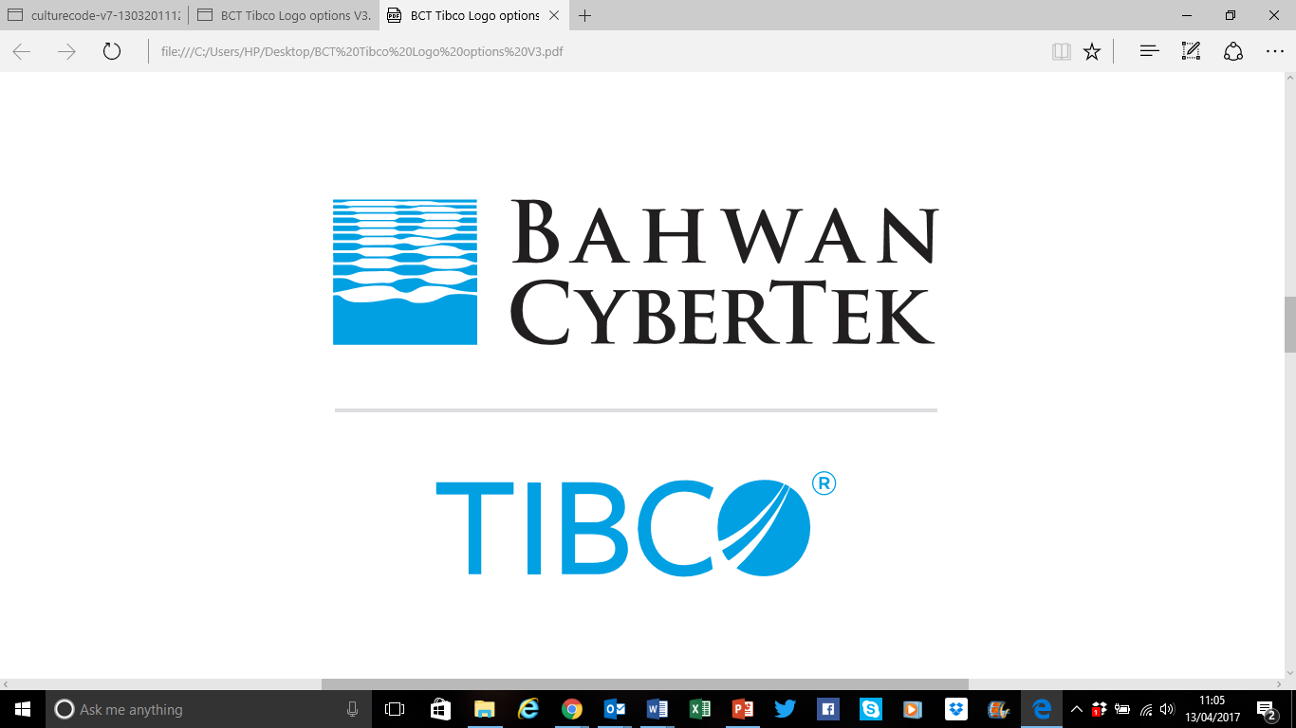

Proposal for

<Solution Name>

<Bid No: If applicable>

Submitted to

<Insert Customer Logo Max height 95 Pixels height x 150 pixels width>

<Customer Name>

Submitted On

**<Date>**

(NOTE: The graphic in the background has to be changed depending on the opportunity)

The data in this document contains trade secrets and confidential or proprietary information of Bahwan CyberTek (BCT), the disclosure of which would provide a competitive advantage to others. As a result, this document shall not be disclosed, used or duplicated, in whole or in part, for any other purpose than to evaluate BCT. Disclosure of any data contained shall be with the express written permission of BCT. The data subject to this restriction are contained in the entire document.

If a contract is awarded to BCT, as a result of, or in connection with the submission of this document, any right to duplicate, use or disclose the data will be to the extent provided in the resulting agreement. This restriction does not limit the rights of the recipient to use the information contained in the data if it is rightfully obtained from another source without restriction.

# Document Control

**Change Record**

| Date | Author | Version | Change Reference |
| --- | --- | --- | --- |
|  |  |  |  |
|  |  |  |  |

**Reviewers**

| Name | Designation |
| --- | --- |
|  |  |
|  |  |

**Distribution**

| Copy# | Name |
| --- | --- |
|  |  |
|  |  |

**Note to Holders:**

If you receive an electronic copy of this document and print it out, please write your name on the equivalent of the cover page, for document control purposes. If you receive a hard copy of this document, please write your name on the front cover, for document control purposes.

# Table of Contents

Cover Letter 5

A. Contact Information 6

B. Experience 7

C. Cost Proposal 23

D. Project Timeline 24

E. Professional References 29

F. Appendix A – Assumptions and Dependencies 30

G. Appendix B - Offerings Overview 32

H. Appendix C: BCT Certifications 37